

Faculty of Engineering

Department of Management Sciences

**PlanSavvy Project Report**

Prepared by:

MSCI 100- Team 13

Tanushree Sharma

Remi Shah

Ishaan Singh

Andy Su

Jane Tong

Date: November 17, 2016

Table of Contents

Overview and Introduction4

About the Tool5

Challenges Faced/Limitations7

Conclusion8

Reference9

List of Figures

Figure 1: Gantt Chart Example5

Figure 2: Buttons 6

1. **Overview and Introduction**

At the beginning of the term each team was tasked with creating a decision support tool (DST) to help make any team project more efficient. The purpose of a decision support tool is to aid the users, or guide them, in the right direction to produce a quality result given a specific timeline for any problem. The tool cannot make decisions for the user, rather, the tool sorts through data such that the users can make more informed decisions as they complete projects. This decision support tool was specified to be Excel based using a wide variety of functions provided therein. Groups were to implement technical knowledge gained during Excel labs along with learning other functions on their own time to create the final DST.

As the current generation looks highly upon the importance of teamwork and group projects, those faced with the challenges of collaboration often find themselves looking for a solution. Team 13 has thoroughly examined the problems which teams face while working on projects and proposed that the major category in which teams have issues with is time management. To counteract this, setting a schedule beforehand allows for project managers to take time to systematically plan tasks, set start and completion dates, and effectively encourage teams to work towards finishing on time. The decision support tool (DST) is created on Microsoft Excel and utilizes a Gantt chart as its base to allow users to see the progress of the overall project. It is also designed to allow users to view what tasks have been completed and not completed by looking at the main interface, also know as the “Dashboard”. It is important to recognize that the DST is an aid to solve the problems; however, the user must also input reasonable effort initially to maximize the functionality and purpose of the tool. The tool is recommended to be used for small to medium scale projects and designed to only display relevant information to the user.

**2. About the Tool**

Improving the functionality of a group/team when working towards completing a project is limited to aspects that do not address user bias. In other words, a decision support tool cannot help fix personal conflicts between team members, but it can improve the efficiency of how the group works together and how tasks are completed. With the use of Team 13’s DST a team will be able to meticulously schedule and track the progress of the completion of the assigned task. The use of Gantt charts, also known as timeline charts, allow users to effectively organize and schedule tasks for each group member while being able to check if each member is staying on task or requires assistance. The tool essentially improves organization, scheduling and communication in a group project. Making the tool as user friendly as possible is of utmost importance, so the tool is based off of two worksheets. The main worksheet houses the dashboard and is the primary user interface. The second worksheet houses the Gantt charts created by the user. Team 13’s tool displays information in the form of a Gantt chart and a simple progress bar such that the user is not overwhelmed by the data. Users can easily extract information from the graphics without searching through multiple worksheets.

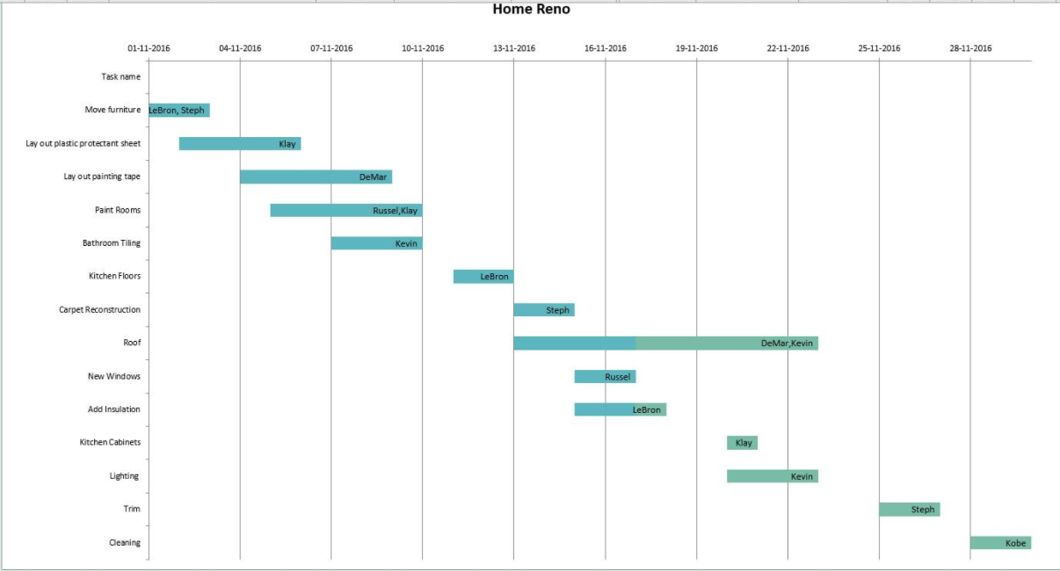

**Figure 1: Gantt Chart Example**

Creating the tool required the use of knowledge learned in Excel labs along with learning new features on our own. There is a heavy dependency on the use of VBA as multiple userforms and modules were incorporated into the tool. The group used userforms to create the prompts for the users to follow while operating the tool.The use of userforms allow users to interact with the program, provides a user interface to make operating the tool straightforward, and also gives users a customized experience while operating the tool. There are simple instructions written on the userforms such that users are able to easily navigate while using the tool. Using concepts learned in class, modules were created in order to run the functions planned for the tool. Modules are the code that allow the functions like buttons and charts to work. Modules and userforms are linked together to run the functions required for the tool. There is a certain degree of freedom of choice on the user’s part through the different userform options provided. Since this tool is meant to be a decision support tool, the group decided to make a Gantt chart for users to track the process of each task, and the project overall. The user can create multiple Gantt charts with different sets of data by using the “sort” function. These charts the user data in different arrangement, giving the user the ability to use the data in more functional formats.

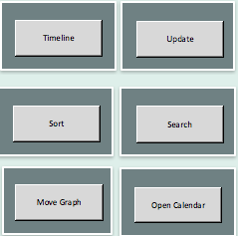

**Figure 2: Buttons**

**3. Challenges Faced/Limitations**

The group was fortunate to have a group member with experience with Excel VBA and coding which made making the tool much less daunting. The other group members made varying levels of effort to learn how to code in VBA in order to complete the tool. During the initial planning of the goals of the tool the group had taken into account the level of proficiency the team collectively had in terms of Excel VBA. The goals changed as each member learned more about the program. One of the biggest problems the team faced was the compatibility with Apple devices vs PCs. Many of the functions that were able to perform on the PC devices were unable to perform on the Apple devices, thus the group decided to make the tool catered for PC users. Team 13 had originally planned to incorporate features that would schedule meetings periodically throughout the allotted time of the project. After closer scrutiny of the functionality of the tool, the team decided that scheduling meeting for the user would not provide any benefit to the efficient completion of the tool. Inputting the scheduling feature required more effort to integrate than the benefits would be provided, and there are more effective methods of scheduling meetings. After realizing this, the team periodically analyzed the tool to ensure that every feature included into the final product would be essential to its function. Adding features for the sake of showcasing Excel competence, but not adding functionality, is extremely inefficient, thus creating functions that could feasibly be incorporated in the allotted time became somewhat challenging. The tool is limited to projects that last longer than one day as the start and end dates cannot be reduced to hours. For example, using the tool on a case day would provide no benefit; however, using the tool for longer projects is the intended use.

**4. Conclusion**

The MSCI 100 term project gave Team 13 the opportunity to learn how to work as a team to a higher degree of effectiveness than our prior experiences gave us. Initially the team was in a state of discord and extremely disorganized as we were unaware of each other’s skills and expectations of the group dynamic. As the term progressed, and the team became more trustworthy of each other’s abilities, working together got easier as the team spent less time figuring out which tasks people are capable of completing and more time completing said tasks. Part of working in a team for a term long project is accepting the fact that not everyone will put in the same amount of effort as the other members of the group. The bulk of the learning occurred after milestone two as the team had begun the process of creating a functioning prototype. At this point the group had a strong understanding of each team member's skills, thus planning and declaring roles became simpler.

After reflecting on the project, the team discovered that there were several areas where we could have improved. Making long term guidelines help create a big picture and display all tasks that need to be completed. A long term view prevents rushed deadlines and allows for a clear and concise plan of action. Reading all the milestone requirements and noting down due dates well in advance would have greatly helped Team 13. Keeping all members of the team updated is the key to productivity in the team. Communication between most group members improved drastically as we began scheduling more meetings to work productively rather than meeting before the deliverable was due. The team also learned how to work efficiently when physically meeting as the team was able to stay on task and work productively.

The tool created can effectively help a team organize and complete a long term project. The learning curve for the technical aspects of the project was difficult to overcome, but the team had to keep in mind the limitations and realistically plan for those. Team 13 learned how to assess if implementing a feature would require the team to expend more energy than the functionality the feature would provide to the overall project. In this way the team was able to learn how to prioritize time to work on including functions that would have a drastic impact on the function of the tool. If the team was given the tool similar to Plan Savvy, the team working process would drastically been improved.

**5. References**

Bernstein, M. (2002). 10 tips on writing the living Web. *A List Apart: For People Who Make Websites, 149*. Retrieved from http://www.alistapart.com/articles/writeliving

Chart.ChartWizard Method Dev, B. (2013). *Chart.ChartWizard Method.Excel*. Retrieved From: [https://msdn.microsoft.com/en- us/library/office/ff838804.aspx](https://msdn.microsoft.com/en-us/library/office/ff838804.aspx)

Range.Cells Property Dev, B. (2013). *Range Cells Property.* [*Excel VBA reference*](https://msdn.microsoft.com/en-us/library/office/ee861528.aspx) [Object model](https://msdn.microsoft.com/en-us/library/office/ff194068.aspx) Chart Object Retrieved From: <https://msdn.microsoft.com/en-us/library/office/ff838804.aspx>

Range.Address Property Dev, B. (2013). *Range Address Property*. [Excel VBA reference](https://msdn.microsoft.com/en-us/library/office/ee861528.aspx) [Object model](https://msdn.microsoft.com/en-us/library/office/ff194068.aspx) Range Object Retrieved From: <https://msdn.microsoft.com/en-us/library/office/ff838804.aspx>

Chart.SeriesCollection Method Dev, B. (2013). *Chart Series Collection Method*. [Excel VBA reference](https://msdn.microsoft.com/en-us/library/office/ee861528.aspx) [Object model](https://msdn.microsoft.com/en-us/library/office/ff194068.aspx) Chart Object Retrieved From: [https://msdn.microsoft.com/en- us/library/office/ff838804.aspx](https://msdn.microsoft.com/en-us/library/office/ff838804.aspx)

SeriesCollection.Add Method Dev, B. (2013). *Series Collection Add Method*. [Excel VBA reference](https://msdn.microsoft.com/en-us/library/office/ee861528.aspx) [Object model](https://msdn.microsoft.com/en-us/library/office/ff194068.aspx) Chart Object Retrieved From: [https://msdn.microsoft.com/en- us/library/office/ff838804.aspx](https://msdn.microsoft.com/en-us/library/office/ff838804.aspx)

Range.SpecialCells Method Dev, B. (2013). Range. *Special Cells. Add Method*. [Excel VBA reference](https://msdn.microsoft.com/en-us/library/office/ee861528.aspx) [Object model](https://msdn.microsoft.com/en-us/library/office/ff194068.aspx) Range Object Retrieved From: [https://msdn.microsoft.com/en- us/library/office/ff838804.aspx](https://msdn.microsoft.com/en-us/library/office/ff838804.aspx)

XlCellType Enumeration Dev, B. (2013). Xl. *Cell type Enumeration*. Add Method. [Excel VBA reference](https://msdn.microsoft.com/en-us/library/office/ee861528.aspx) [Object model](https://msdn.microsoft.com/en-us/library/office/ff194068.aspx) Range Object Retrieved From: [https://msdn.microsoft.com/en- us/library/office/ff838804.aspx](https://msdn.microsoft.com/en-us/library/office/ff838804.aspx)

Select column in a selected range VBA Makah. (2014). *Select Column in a Selected Range VBA*. Stack overflow Retrieved From: <http://stackoverflow.com/questions/25185187/select-column-in-a-> selected-range-vba

VBA code to name a worksheet Andrew.p. (2003).*VBA code to name a worksheet*. Mr. Excel Retrieved from: <http://www.mrexcel.com/forum/excel-questions/51686-visual-basic-applications-code-> name- worksheet.html

Move a chart to another worksheet Beetle. (2013). *Want To Move Excel Chart to Last Tab Using Access VBA*. Microsoft Access Retrieved from: <http://www.access-> programmers.co.uk/forums/showthread.php?t=244542

Dynamic Gantt Chart in Excel- Dates Update Daily [Teach Excel]. (Aug 11,2008). *Make a Dynamic Gantt Chart in Excel*- Dates Update Daily

Ubound Dev, B. (2013).*Ubound Function*( Visual Basic. [Visual Basic Reference](https://msdn.microsoft.com/en-us/library/sh9ywfdk(v=vs.90).aspx) [Functions](https://msdn.microsoft.com/en-us/library/32s6akha(v=vs.90).aspx)  [S-Z Functions](https://msdn.microsoft.com/en-us/library/95b8f22f(v=vs.90).aspx) Retrieved From: <https://msdn.microsoft.com/en-us/library/office/ff838804.aspx>

Arrays Dev, B. (2013). *Arrays in Visual Basic*. [Visual Basic](https://msdn.microsoft.com/en-us/library/2x7h1hfk.aspx) [Visual Basic Programming Guide](https://msdn.microsoft.com/en-us/library/y4wf33f0.aspx)  [Visual Basic Language Features](https://msdn.microsoft.com/en-us/library/wak0wfyt.aspx) Retrieved From: [https://msdn.microsoft.com/en- us/library/office/ff838804.aspx](https://msdn.microsoft.com/en-us/library/office/ff838804.aspx)

## Erez. (2011*).* [*How to Create Progress Bars in Excel With Conditional Formatting*](http://www.howtogeek.com/howto/45677/how-to-create-progress-bars-in-excel-with-conditional-formatting/). How-to-Geek Retrieved From: http://www.howtogeek.com/howto/45677/how-to-create-progress-bars-in-excel-with- conditional- formatting/

Work Term Reference Vulpes R. Hood.(2011). *Guidelines for Management Engineering Work Term Reports.* University of Waterloo Facility of Management Sciences. Retrieved From: https://uwaterloo.ca/management-sciences/sites/ca.management- sciences/files/uploads/files/WorkTermReportGuidelines.pdf